Description

Dungeons of Python it is a mix of rogue-like and jRPG. You are a player (The Choosen One), who need to cleaned up old programming dungeon from virus, stupid junior develop from iTechArt, bugfixies etc. (Hello from origin Diablo)

Base interface looks like:

Control hits
Player Room
Player
Enemy/chest
Mini-map

Health-bar

Lvl, exp, coins

You have a goal – go deeper and deeper to main boss. Every level – is a floor, and avery floor – its several rooms, connected by tonnels. You can see that in mini-map. Its looks like:

Start

monster
monster
Difiicult monster with chest

Med. chest

finish

NPS
NPS
You have 3 activities:
1. Monster: you must to fight with him. Fighting looks like resolve some programming abstract task, and you need write code quickly and right. Monster(read - task) difficulty depends on our level, inventory and monsters level.
# Strength, level and Inventory can’t affect on resolving programming tasks. U can’t deal more dmg bcz the first and only one purpose of the game is to study.
# All of it just for competition between gamers. Most difficult dungeons has more beautiful loot.

2. Chest: you need to hack the lock. Hacking – quick quiz about programming questions. For example, we have easy lock and you need to answer two questions. For hard lock you need to answer five questions.
# master keys if given by passing challenges and killing common mosters, it has 20% chances to drop. The drop of chest is visual loot (that has no affect on your dmg), headling salves and experience boosters.

3. NPS – it’s your teammates. If we want to see him in our hub-room(yes, we have a hub room...maybe bar?), we need to small talk with him. Its visual novel segment with right answer.(just for loolz)
# idk

Player has inventory with items and levels with abilities. Also we have global level with achievements.
# The inventory loot has no affect to regular bosses after dungeons, only for daily raidboss, loot deals more dmg

Inventory: we have classic diablo-system of color-items with programming references (DRF-shield, Kafka-sword, jQuerry pants etc.).

Types of items:
1) Head (hats, helmets etc)
2) Arms ( different weapons and shields)
3) Legs (pants, shoes etc)
4) Body (Javascript dress, geek coat)

Level system: we have several levels, like intern, junior, junior+, middle etc. And we have characteristics, like in classic rpg, but with developers abilities, for example:

In classic RPG | On our RPG
Strength | Backend
Agility | Frontend
Intelligence | Devops
Charisma | Soft skills
Luck | Another developers in project (loolz)

New level → we can add 1-2 points to different skills, after that we can use powerful items. All of this stuff using to create task during battle easier or you can take a hint or something like that.

Interface during battle, NPS talking and fight – need to discuss.

RAIDBOSS

Raidboss is the weekly event. Boss drops rare loot, it is stronger then other dungeon bosses. The main thing is to cooperate with other developers and beating it with small groups under 4 persons.

LOGIC OF GAME

1 st steps in game
Player has to choose the path

frontend

backend
testing

player

After choosing a path player sees dungeons roadmap

circle is a dungeon

you can open next dungeons only with a loot-key from previous dungeon

Dungeon is a theme of learning.

After choosing a dung player gets into the floor

floor is one of themes of learning

floor has rooms in it

room is the single lesson of learning theme

rooms are separated to learning room and bossfight room
after every learning room goes bossfight room
after every bossfight goes learning room

learning bossfight learning bossfight learning

the last room on the floor leads into next floor

when you fall into the last floor thereis global dungeon bossfight

After beating dungeon the main boss drops special loot to access the next dungeon, player getting new achieve, spell and a pet.

Spells are for weekly bosses, every spell has features like firing, freezing, stun, it has calldown.
Spells are connected with some dev technologies: python bite, flasks heat.

Pets are also for weekly bosses, it has a chance to protect you from some type of spells (magic, fire, water). After protect it goes on calldown.

Achieves gives you experience, that grows your level up, gives you score points.

PLAYERS PROGRESS

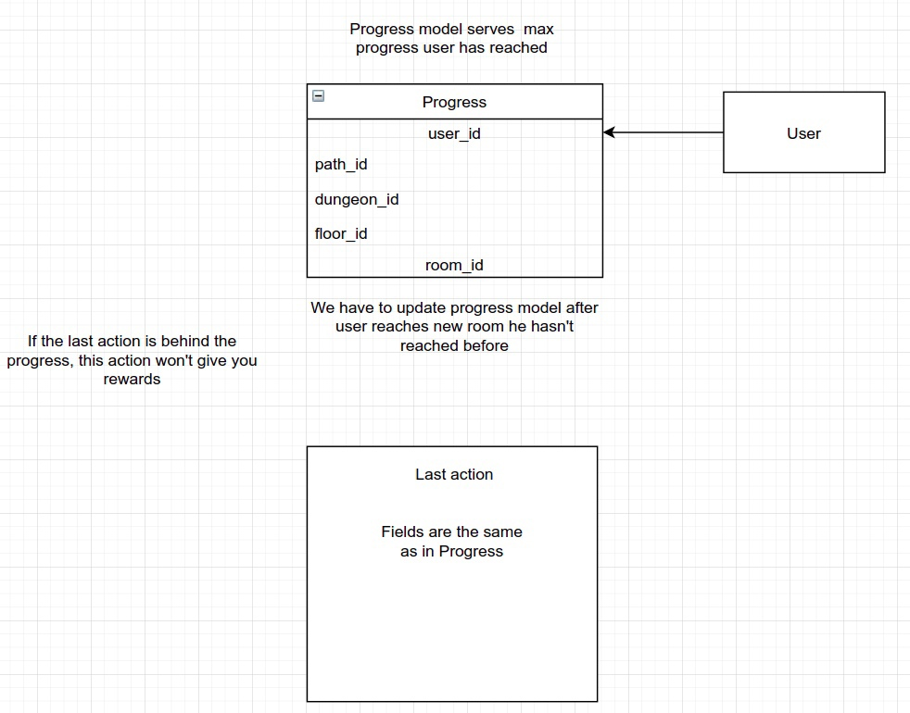
LOGIC

Progress
1. Progress is connected with user as FK. User can have more than 1 Progress entities for every path he starts. UNIQUE TOGETHER for Progress is [‘user’, ‘path’]
2. After user hiting a new high (ending new room/floor/dung/) we update Progress entity filtering by user and path.
LastAction

1. After user doing some action in game we must update LastAction entity. Last action is connected to user as ONE TO ONE.

EXPLANATION
USER INTERACTION WITH GAME

1. After user ends dung/floor/room/ by (dung, floor, room)/end url will be invoked function that checks – IF THIS ROOM/FLOOR/DUNG IS FURTHER THAN PROGRESS
1.1 update Progress entity
1.2 give rewards
1.3 return url to the (dung, floor, room)/next

IF THIS ROOM/FLOOR/DUNG IS BEHIND OF PROGRESS
1.1 don’t give rewards
1.2 return url to the (dung, floor, room)/next

